**Automated Detection of Cyberbullying Occurrences in Social Media Posts Through Text Classification Using Support Vector Machine (SVM) Algorithm**

**Submitted by:**

Samantha Mallari | Faith Ballesteros | Eva Samillano

(SCSPROJ – SS141)

**ABSTRACT**

Social media is defined as an electronic form of communication wherein people can create, share, and exchange information in the virtual community. Nowadays, it has significantly increased the communication platforms. Consequently, as the social networking domain expands in the cyberspace, it inevitably creates more opportunities for cyber bullies to oppress internet users. Cyberbullying is defined as an aggressive behavior in the cyberspace. It involves repeatedly making threats, sending provocative insults or racial slurs, bashing, and sending of spam messages. Recent studies indicate that cyberbullying has become a pervasive problem around the world and it is tremendously alarming. However, given the massive information on the Web, there is a need for intelligent systems to identify potential risks automatically. By using social media sites such as Facebook, Youtube, and Twitter as sources for model training, the team proposes a support vector machine base model for detecting events of cyberbullying present in public social media posts and further classify them based on sensitive issues in the Philippines. The optimal model can generate an accuracy of 70-80% in terms of detecting cyberbullying posts.

Keywords: *Cyberbullying*, *Detection*, *Implications*, *Social Media*

**INTRODUCTION**

* 1. **Background of the Problem**

Long before men evolved into species of higher intellectual capabilities, bullying was believed to have been evident. Boehm (2012) stated in his book, Moral Origins, that primates, specifically monkeys and chimpanzees, frequently execute bullying-like deportment against members of their own kind. The said behavior would, in turn, provide them an edge in terms of social stature, acquired resources, and reproductive "opportunities" among the rest. Upon the rise of the Homo-sapiens (the genus into which humans of today are classified), the purpose of bullying was redefined from social dominance to a mere destructive act. Hogan Sherrow, an anthropologist, believes that "the ability of language to facilitate communications, coordinate behaviors, and express thoughts and gossip has completely altered the form and intensity of bullying". Fast-forward to the 21st century, likewise known as the era of widespread technological advancements, a new form of bullying emerges - cyberbullying. Cyberbullying is referred to as "modern-day bullying". For any ill-treatment to be considered as a form of cyberbullying, it should meet the following criteria: involuntary – the offensive action happened deliberately or intentionally; repetitive – the mistreatment has been reportedly known to be occurring recursively; harmful – the deed has brought upon negative feedback toward a particular person (or groups of people), and has utilized technology as his/her medium for accomplishing the said feat (e.g. through text messages, instant messages, emails, and the like). Altogether, they give meaning to the term cyberbullying as the “willful and repeated harm inflicted through the use of computers, cellphones, and other electronic devices”.

With the immense number of new gadgets being introduced into the market almost every year and the accessibility of acquiring a reliable internet connection, the probability of people engaging in different social media websites, forums, blogs or other forms of social communities online are not likely to decrease. Similar scenarios apply to the Philippines. A survey entitled, "Southeast Asia Digital in 2015" which was conducted by the people behind "We Are Social", a global agency dedicated to delivering world-class ideas with forward-thinking brands, indicated that the Philippines ranked 5th out of the 11 countries in Southeast Asia in terms of social media usage (based on the number of active Filipino social media users). Consequently, it leads to the formation of virtual “hang-outs” of some sort. And whenever groups of people are involved, specifically in areas where admin or moderator supervision is limited, the occurrence of cyberbullying becomes inevitable. The alarming fact about cyberbullying is that it can be done by anyone (including people whom the victim is not familiar with), in an instant, and may spread across different areas, harming a person without other people’s knowledge.

From being dubbed as the “Texting Capital of the World” to “Social Media Capital”, the Philippines had proven itself enough to be recognized as an overly social country. As of January 2016, the aforementioned global agency ("We Are Social") reported in their annual digital, social, and mobile statistics that the number of active social media users in the Philippines amounts to 48 million. While the existence of these particular types of media provided ample benefits with regard to improving former communication-related processes, such sites have likewise been considered as the launch-point of common cyberbullying assaults occurring within the country. According to a 2015 survey administered by a child-care nonprofit Stairway Foundation Inc, 80% of Filipinos have been cyberbullied through social media. Even celebrities were known to have been targets of cyberbullying attacks as well. Recently, a radio DJ, Karen Bordador has experienced extensive cyberbullying, following her arrest with her boyfriend in a drug-related buy bust operation.

In order to mitigate severe cases of cyberbullying in social media, the Republic Act 10627, also known as the Anti-Bullying Act of 2013, was introduced. It recognizes cyberbullying (as one of the types of bullying inclusive in the said law) as a major offense, specifically when elementary and secondary students are the people involved, and provides appropriate provisions on the consequences of their actions. This means that the law was mainly focused on school-related cyberbullying occurrences - those that took place between classmates regardless of whether it happened inside or outside the campus. However, Camarines Sur Rep. Rolando Andaya Jr. noticed that the scope of the said act (particularly with regard to cyberbullying) remained inefficient. Instead, he proposed a bill (known as House Bill 5718 - Anti-Cyberbullying Act of 2015) which hopes to extend the definition of cyberbullying (in terms of the people affected) and its respective countermeasures. In spite of the fact that improvements in the mitigation of such incidents can possibly be presented by the bill, it was yet to be approved by country's lawmakers as an official law. Oddly enough, despite the dangers cyberbullying can inflict on an individual, only a small number of reports are continuously being submitted voluntarily to designated authorities. Dr. Ryan Guinaran, Ph.D. claimed that the latter was due to the fact that cyberbullying in the Philippines (in comparison to other countries) tends to be more on a conservative level. If Filipinos continue to practice this type of passive attitude regarding the matter at hand, then even with the efforts granted by the government and NGOs alike, cyberbullying will still persist. Thus, instead of waiting for the parties involved to voluntarily explain their side to the people concerned, the group had the thought of taking advantage of the same platform where the aforementioned event was known to have been rampant – technology – as a countermeasure to cyberbullying.

* 1. **Statement of the Problem**

How can the Support Vector Machine (SVM) algorithm be utilized in the process of automating the method of detecting cyberbullying occurrences in public social media posts through text classification?

**1.3 Objectives**

**Main Objective**

This research aims to formulate a cyberbullying detection model which will yield at least 70-80% accuracy in terms of detecting cyberbullying occurrences present in public social media posts.

**Specific Objectives**

* To acquire ample data for the corpus
* To apply text pre-processing to the statements included in the dataset
* To extract significant features from the corpus
* To evaluate the extracted features
* To classify the weighted features in their respective classes (predefined classes)
* To combine groups of classes in any way possible
* To compute for the Precision, Recall, F-measure and Kappa Statistic for each group that is being experimented on
* To verify the model’s accuracy with the help of the SVM algorithm

**1.4 Significance**

The creation of a cyberbullying detection model (which will be patterned according to selected cyberbullying statements found in social media posts bearing sensitive issues as perceived by the many) will greatly contribute to the improvement of social media monitoring. As of today’s time, online moderators have been utilizing the manual way of flagging offensive posts in social media sites (Van Hee, 2015). In 2001, the Children’s Internet Protection Act (CIPA) was enacted to address concerns on children’s access to visual offensive content over Internet. To comply with CIPA requirements, administrators of social media often manually review online contents to detect and delete offensive materials. In Japan, the Parent Teacher Association (PTA) performed website monitoring called “net-patrol”. In this method, once a harmful post was detected by a net-patrol member, he will immediately report it to the administrator. However, despite the efforts made by the authorities, it is unattainable to monitor activities occurring in the cyberspace from time to time. Most importantly, the previous methods were labor intensive, time consuming and not scalable in reality (Vinita, 2014). With the cyberbullying detection model that can be integrated to social media sites, the process of detecting harmful entries online will be automated. Furthermore, vicious posts will be swiftly and easily flagged and subjected for analysis (by the moderators) without rendering the moderators to keep an eye out for such statements in the site 24/7.

In 2016, a survey that was conducted by We are Social found that 47% of the Filipinos are active social media users. As the number of social media users tremendously increases, it consequently intensifies the cyberbullying problem (Chen et al., 2012). Another survey that was conducted by child-care non profit conclude that 80% of Filipino teenagers are victims of cyberbullying. Indeed, it has become rampant in the Philippines (Cheng, 2016). Social networking sites possess notable characteristics that make it an indulging tool for cyberbullies. These characteristics include the following: real time updating, wide spread dissemination of personal information, a rallying point for people, anonymity, instantaneousness, ability to reach large audience, cheap, connected to power dynamics, information posted in social media has a tendency go viral, it allows other social network users to generate comments, it builds up and can generate support from others, and it is very empowering (Gonzales, 2014). Nowadays, social media sites are beginning to adapt to an easier, user-friendly approach to reduce and possibly eliminate cyberbullying (White, 2012). Facebook provides tools and resources that will help their user to protect their account and report offensive content. In the privacy setting, the user can specify privacy for a specific message or post and limit how much information can be visible to others. Users can also report offensive posts and categorize which way the post is harmful to them to determine the issue and its magnitude. As for Facebook pages, administrators can set up a keyword moderation blocklist and enable a profanity blocklist that filters posts and comments by users into their page. Once the user includes a blacklisted keyword in their post, it will be automatically identified as spam. On the other hand, YouTube provides reporting tool wherein a user can flag inappropriate videos with hate content, nudity or graphic violence and report abusive comments. As a result to this, YouTube will verify if a certain video or post violates their terms of use before removing it permanently from their site. However, these methods imposed by social networking require users to take actions such as reporting posts or enabling plug in before they can execute appropriate action for it. Most people, typically Filipinos, are reluctant to admit to being victims of cyberbullying (Andrade, 2012). One of the possible reasons would be because they do not want to further instigate a conflict on the opposing party and that they thought that what the bully had done is not that much of a big deal (NCPC, 2007). Despite how much or how long the effect of the statement dwells on the person, at that point in time when the victim reads it, he or she will still get affected by it one way or another (Bersola-Babao, 2012). Therefore, even if there are only traces of cyberbullying occurrences present, it is still encouraged by the experts not to turn a blind eye over such statements. In order to address these issues, a cyberbullying detection model will be designed to detect even subtle posts implying cyberbullying attacks as much as possible. Thus, the model can be integrated by the system developers in order to be fully functional before it can automatically extract harmful information from the Web. And since the team based the model in the Philippine context, it can detect offensive posts written in Tagalog and English offensive posts.

One of the beneficiaries of this research are the system developers. They can implement the model to an automatic cyberbullying detection system, which can be further integrated to social networking sites to detect any events of cyberbullying in the cyberspace. Through the use of this model, the system can detect posts as long as it notices potential cyberbullying activity - even minor ones as much as possible since the model can generate an accuracy of at least 70-80% in terms of detecting cyberbullying occurrences present in social media posts.

The findings of this study will redound to the benefit of researchers who want to explore the field of both Cyberbullying and Natural Language Processing (NLP) techniques, specifically, in Text Classification. Since NLP is a broad field of study, the team will merely focus on the creation of cyberbullying model that will automate the process of detecting harmful entries in social networking sites through text classification using Support Vector Machine. As a result to this, the study can help researchers gain a better understanding on the processes of text classification and the incorporation of the model with Linear Support Vector Machine Algorithm. As for the researchers who want to explore the field of cyberbullying, this study can further enhance their knowledge on what cyberbullying is, the classification of cyberbullying and non-cyberbullying events, and the different categories of cyberbullying, based on sensitive issues in the Philippines.

The younger population tend to visit social media websites more frequently than the rest (Cheng, C. & Ng, L. 2016). A research that was conducted by National Crime Prevention Council (NCPC) concludes that teens ages 13 to 17 are an online population. Over 80 percent of teens use their phone regularly, making it the most popular form of technology and a common medium for cyber bullying (Cyberbullying Research Center, 2015). A survey that was conducted in the US, with a sample size of 935 teens with age ranging from 12 to 17 years old, found that 4 out of 10 teens are victims of cyberbullying (Lenhart, A. 2007). Adolescents have a tendency to deal with things impetuously due to their immaturity. They are most likely unable to identify the intensity of the damage that they had done until it finally occurred (Li, Q. 2006). As online platforms are increasingly used for cyberbullying, it poses a threat to teenager’s mental and physical well-being (Price, M. 2010). Thus, it can lead to depression, low self-esteem, poor academic performance, self-harm, and suicide (Hinduja, S. 2010). However, once the cyberbullying detection model is integrated into social networking sites, such incidents may be prevented before they get out-of-hand.

Although parents are vigilant about protecting their children from the content of sites and poses limits on the amount of time spent online, teens report shows that they are largely unsupervised by their parents online (NCPC, 2007). Recent survey shows that 73 percent of the parents keep the home computer in an open family area—either purposefully or inadvertently providing at least casual surveillance of the online activities of youth at home (Lenhart, Madden, & Hitlin, 2005). Other research has determined that 54 percent of parents use some type of Internet filter, 62 percent check up on the Web sites their children visit, and 64 percent have specified rules for the time their children spend online (Lenhart et al., 2005). However, despite these efforts made by the parents, teenagers can easily find a way to visit objectionable Web sites or participate in inappropriate online behavior (Corwin, 2008). In addition to this, an Internet Safety Coordinator from Illinois, Jace Galloway states that relying solely on parental control inside the house is insufficient because children can access the Internet from various locations. By integrating the cyberbullying detection model in social networking sites, it can help them monitor the different activities of their children in the cyberspace.

**1.5 Scope and Limitations**

The cyberbullying detection model will be developed based on the typical constituents of Filipino cyberbullying statements as to how they were perceived (with regard to the said concept) by individuals living within Metro Manila. Statements that were used to populate the corpus were extracted from social media contents which many Filipinos deemed controversial (e.g. regarding inappropriate behavior, gender, and the like). The researchers believed that if they were to get their statements on the said areas, they will be able to get the gist of what most Filipinos will refer to as “offensive”. About 30001 statements extracted from these posts will be used in the entirety of the corpus. This will be further divided into two (with the other half of the corpus to be used as training data). On the text pre-processing phase, the annotation of the statements will be based according to the results that will be given to them by their respondents in an interview. 20 people (of different background) will be given at most 20 different sets of questions which they will annotate in terms of whether or not the phrase implies occurrences of cyberbullying. Subsequently, they will also be required to state the reason as to why they labeled a particular statement as a cyberbullying statement (considering that the aforementioned statement was labeled under the said category by them). The said annotations will likewise serve as the classes which will be utilized during the feature extraction stage experimentation stage. The team also considered the following text pre-processing methods (apart from the text annotation process) as of this moment: tokenization and removal of extra characters (cleaning of the dataset). The feature extraction stage, which follows after the text pre-processing phase, will involve the use of an algorithm known as Bag-of-Words (BoW) to extract the features in every category (or class). These features will then become the basis for the model’s performance during the testing stage. The adjustments that will be made (e.g. the possible removal or inclusion of more features in the training data to improve its accuracy rate) against the Support Vector Machine (SVM) algorithm will take place in the experimentation stage.

The members of the group had decided that the cyberbullying detection model will remain intact with WEKA toolkit and will be presented in that way towards the panel for the sole purpose of demonstrating how the detection process would work.

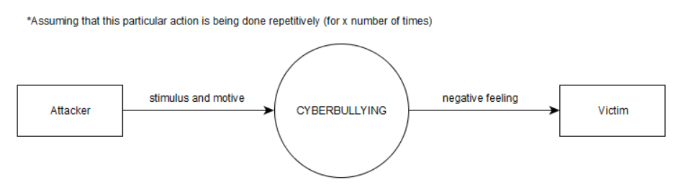**1.6 Context Diagram**

**REVIEW OF RELATED LITERATURE**

**Related Studies**

Dinakar et al. (2011) created a model for the detection of textual cyberbullying. The dataset for their study was obtained from YouTube for comments posted on videos through the use of YouTube PHP API. The data were grouped into clusters of sexuality, race and culture, and intelligence. The datasets for each cluser were divided into 50% training, 30% validation and 20% test data. Each dataset was subjected to three operations: removal of stop-words, stemming and removal of unimportant sequence of characters. Then they select and populate feature space for three supervised learning methods along with a Naive Bayes classifier: JRip, J48, and SVM. At the first part of their experimentation phase, binary classifiers were trained on each three datasets for each of the labels, namely, sexuality, intelligence, and race and culture to predict if a given instance is classified into its respective label. At the second phase, the three datasets were combined to form a new dataset for the purpose of training a multiclass classifier. Lastly, the trained models were evaluated through the use of a kappa statistic. Although JRip yield the highest accuracy, its kappa values were lesser compared to SVM. Thus, SVM's high kappa values implies better reliability for all labels.

In 2012, Dadvar, Jong, Ordeiman, and Trieschnigg conducted a study on Improved Cyberbullying Detection using Gender Information. The team believes that developing gender-specific features would lead to more accurate classification of harmful contents. In their study, they used a supervised learning approach to detect occurrences of cyberbullying; moreover, they created a Support Vector Machine classifier using Weka. As for their dataset, they gathered posts from MySpace then compared the most frequently used foul words by each gender through the use of Wilcoxon signed rank test. For their baseline, the researchers used four types of features: profane words, second person pronouns, other pronouns, and the TFIDF value of all the words in each post.

In 2015, Kansara and Shekokar proposed a framework for detecting negative online interactions in terms of abusive contents carried through posts or comments as well as images. They believe that the combination of text and image analysis techniques can yield an efficient result for detecting potential risks of cyberbullying. The framework aims to detect abusive image or text and block it immediately before it can be disseminated to the cyberspace. The designed framework has two modules: abusive image detection and abusive text detection. The process of abusive image detection begins from feature extraction wherein the Local Binary Pattern (LBP) will be used to detect and describe interest points of an image. The extracted features using LBP will be mapped to the existing visual word in vocabulary. The event of certain visual words provides powerful hints for the presence of offensive content in an image. Finally, SVM is used for classification thereafter. Given a set of training images to the classifier, each image marked as belonging to abusive class if given image contain abusive or pornographic contents. SVM training algorithm builds a model that assigns new image into abusive categories by applying the learned rules to identify abusive images. As for the process of abusive text detection, the system will perform pre-processing of the text messages and bag of words is applied for extracting the features of the message. After the feature extraction, the matrix is generated which is used by the Naive Bayes model to categorize abusive text messages. At the final stage, the Boolean system is used to categorize cyberbullying or non-cyberbullying event by analyzing the result obtained by both the image and text classification.

Marathe and Shirsat (2015) proposed a mechanism that can automatically identify videos and users promoting cyberbullying, using a set of discriminatory features and classification algorithms. The proposed solution is a multi-step process primarily consists of three phases: training and testing profiles collection, dynamic model building, and an implementation based on Naive Bayes algorithms. In the first phase, the researchers collected positive training dataset (which contains occurrences of cyberbullying). Through the use of YouTube API, they were able to download the availble meta-data of several relevant videos. Furthermore, the meta-data will be extracted to build the training set. In the second phase, they use character n-gram based approach to build a dynamic model from these training profiles. In phase 3, they built a system based on Naive Bayes algorithm. It is based on Bayes rule for text classifications. It takes one video as an input, finds an extent of textual similarity between this video metadata and the training data. Based on the probability score, a video can be classified as relevant cyberbullying promoting or irrelevant.

Van Hee et al. (2015) conducted a research on Automatic Detection and Prevention of Cyberbullying. The team presented the construction and annotation of a corpus of Dutch social media posts annotated with fine-grained text categories, such as insults, threats, sexual talk, defamation, defense, and curse. The participants in a cyberbullying context were also identified in order to enhance the analysis of human interactions involving cyberbullying. Initially, the researchers had decided to use this particular research paper as their main basis for creating the project; however, the process of manually annotating the statements within the dataset, according to the aforementioned fine-grained text categories, proved to be difficult as some of the categories were closely related to each other. Additionally, the succeeding methods after the data annotation process proved to be difficult to comprehend given the current knowledge the researchers possess under the NLP field.

In 2016, Cheng and Ng conducted a research at De La Salle University. The research aimed towards detecting cyberbullying roles through textual context in Facebook and Twitter. First, the researchers identified six roles in a cyberbullying context: the bully, victim, assistants of the bully, reinforcers, outsiders, and defenders. Among the three algorithms used by the researchers such as Naïve Bayes classifiers, decision trees and Support Vector Machine (SVM), the SVM had the highest accuracy. The optimal model produced an accuracy of 59.7% in detecting the bullying roles; while detecting the bully role produced an accuracy of 80.9%. The researchers are currently using this study as their basis in the creation of their proposed cyberbullying detection model because unlike the other study (as mentioned before), they found this paper easier to comprehend. It gave them a clear picture of what they should do in order to achieve their desired output. Additionally, since SVM has been proven to be the most accurate model, the researchers were also planning to use SVM in automating the detection of cyberbullying occurrences.

Sugandhi, Pande, Agrawal, and Bhagat (2016) proposed a system for automatic monitoring and prevention of cyberbullying through the use of machine learning. The data was collected from Twitter through the use of Twitter API while the labeled training data was gathered from ChatCoder. The collected data is then preprocessed and passed on to the classifier. The team tested the accuracies of various classification algorithms (Naïve Bayes, Support Vector Machine, and KNN) in the detection of cyberbullying on their training data. Among the three algorithms used, SVM was said to be the most consistent and yields the highest accuracy. The sentiment of the statement is calculated in parallel with the SVM classification; moreover, the sentiment analysis system employs a method in which it assigns polarity values to each statement based on a certain formula. The multiclass SVM takes the bullying data and classifies it into three different classes namely low, medium, and high depending on its harmfulness level. Lastly, once the post is put into its respective class, a response grading system implemented by the researchers is executed. The system will give response based on the class in which the post will be categorized: low level post will result in a popup in the form of a reflective user interface while a high level post will result into a temporary ban.

Sintaha et al. (2016) proposed a system for cyberbullying detection using sentiment analysis in social media. The data was gathered from Twitter through the use of Twitter API. For the data pre-processing, the team corrected the spelling mistakes in the tweets, converted the uppercase letters to lowercase order, remove usernames, URLs, and unnecessary white spaces, and emoticons are replaced with the corresponding word that defines the emoticon to find out polarity of the tweets. In their dataset, they use 80% of the dataset for training and 20% for testing. The team also used an automated training set classifier wherein they can collect thousands of tweets and run an algorithm through those tweets to classify whether the word is positive or negative. For their baseline, they used four types of features: stop words, repeating letters, punctuation, and words with alphabets at the beginning. Furthermore, the dataset were retrieved from database, classified and run through three machine learning classifying techniques (SVM, Naïve Bayes Classifier, and Convolutional Neural Network) to compare the performance of those algorithms. After the classifier has been trained, the test tweets were run through the classifier to detect the polarity and after it has been detected, it was used to compare the accuracy of the classifiers. Among the different approaches, SVM generate the highest accuracy followed by Naïve Bayes.

**THEORETICAL FRAMEWORK**

In his book “The Presentation of Self in Everyday Life”, Ervin Goffman introduced the mechanisms of audience segregation. He describes how people play different roles in different situations. It is a mechanism wherein an individual perform roles, in order to create a favourable image of themselves and leave a good impression to others that is linked to the role they perform. The role that the individual performs is based on who their audience is.

Nowadays, more and more people are getting inclined to social networking sites because it provides an easier way for social interactions and communications. These sites allow users to share personal information about themselves through text, pictures, and other forms of media which in turn, creates an image for each user; however, the representation of oneself in the cyberspace is on a global scale in front of an audience which is possibly unknown and infinite. In social networking sites, the user’s privacy is threatened because a large audience might have access to his personal information. In order to handle privacy issues, there were few social media sites that offer limited options for making one’s profile visible for a specific set of individuals. As for some cases, audience segregation is used as a solution to protect user’s privacy; however, Goffman’s segregation of audiences is a lot harder in the era of the Internet. Difficulties begin when the audience is used to a certain type of performance from an individual or team but observes another performance which does not create the same impression which results to cyberbullying. The impression created on a social networking profile may not resemble an individual’s real life identity.

The nature of communicating in the cyberspace facilitates the potential for anonymous interactions. It was discovered that bullies who choose to use electronic means can easily hide their real identity and make themselves anonymous. Anonymity can be created through the use of temporary email addresses, fictitious names or unknown mobile number. The perception of anonymity in social media serves as a disinhibitor so that people are more likely to do and say things online that they would not do or say in a face to face situation. Another key characteristic of cyberbullying is the potential to reach a limitless audience. Due to the boundless nature of cyberspace, the audience is not confined to a single setting (such as school or office) but has the potential to be viewed by a global audience.

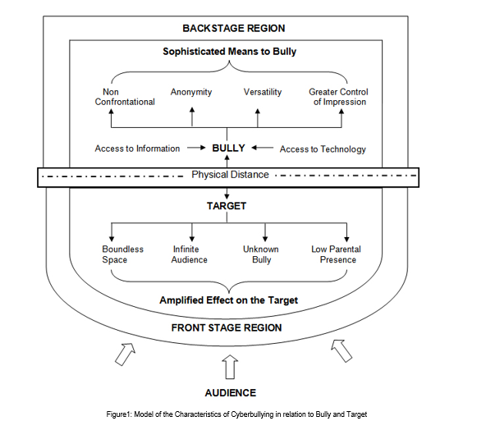

Goffman's framework offers not only a way of thinking about space in terms of performance but also a way of thinking about how people may act differently depending on the audience and setting which are relevant to an exploration of cyberbullying. Goffman defined three roles in this mechanism: performer, audience, and outsider. These roles can be paralleled to the roles of a target, bully, and bystander. By framing bullying as a performance, a framework is provided that enables us to consider the bystander group as an audience and how different settings may affect how young people act towards others. In order to set the scene for a performance, Goffman made a distinction between the two regions of social space where an individual interacts. The front region is defined as the public performance area. The backstage region is a place wherein the performer can privately prepare for the performance or where members of a group can openly construct the impression they are planning to give. By using Goffman’s framework of performance, cyberspace interactions can be executed by the bully in the backstage region which impacts on the target in the public front stage region. As the backstage region is a place that performers may privately prepare away from the audience, this provides time and space for the bully to plan the ways in which they wish to target others. The physical distance which cyberspace interactions facilitate may also result in the bully managing the impression ‘given off’, the ability for the bully to conceal their identity and the tone and meaning being open to wider interpretation.

**Natural Language Processing**

Natural Language Processing (NLP) is a field of study which focuses on discovering ways on how to bridge the gap between interactions involving humans and computers. It aims to provide a method for computers to analyze and comprehend natural languages (a.k.a. human languages) in an intelligent way, or by means of simulating the process of "understanding" - either through Symbolic approach, which utilizes a set of predefined rules, modelling a different language phenomenon, or Statistical approach, which makes use of machine learning algorithms to learn the language phenomena. Concepts in computer science, artificial intelligence (AI) and computational linguistics are what comprises NLP. After all, Natural Language Processing is said to be the main component of AI and that it relies on machine learning as well - in order to enable the system to derive patterns in a given dataset which would help improve its own understanding of speech. It differs from common word processor operations in such a way that NLP possesses the capability to analyze the word for its meaning rather than only for its structure (viewing the word in a symbolic approach).

A great number of current software applications have been incorporated with NLP tasks in order for them to function appropriately. Some of those tasks are as follows:

* Deep Analytics
* Machine Translation
* Named Entity Extraction
* Co-reference Resolution
* Automatic Summarization
* Sentiment Analysis
* Text Classification
* Conversational Agents

A system’s skill that could count as an example of a Natural Language Processing capability would be developing a decent conversation in pure human language. Likewise, computer systems that can convert human languages to computer languages and vice-versa are currently existent. Translation programs were also made possible by NLP. Additionally, grammar and spelling checkers were also programmed following the mechanism of implementing text processing techniques under Natural Language Processing. Lastly, a computer that can read human languages (in publications such as books) is also a product of NLP.

Despite the current capability of NLP in terms of Human-Computer Interaction, it still remained limited particularly in producing statements which involved 100% human reasoning and logic. NLP can only refer to a stricter subset of the human languages which means that it cannot allow anomalies which are often occurring in a particular human language.

**Textual Corpus**

Or simply **corpus**, is a collection of large sets of text specifically chosen by the researcher (or linguist, in terms of linguistics) to deduct his/her own linguistic analysis – may either be statistical analysis and hypothesis testing, checking occurrences or validating specific rules - in the text of interest. In the field of Natural Language Processing, the analysis conducted can be used as a basis or test bed for constructing NLP systems. They are typically processed and stored electronically (with the use of databases, etc.) in today’s time.

**Corpus Annotation**

The method of adding linguistic information to the data included in the corpus is known as corpus annotation. The most common type of annotation being done to the dataset is by putting labels or tags which indicates the class to which a particular word in the body of text belongs to.

**DESIGN AND METHODOLOGY**

In this section, the researchers illustrate their understanding on the process of creating a cyberbullying detection mechanism.

**The Creation of the Corpus**

**Data Collection and Annotation**

The team acquired data from Youtube. A total of 625 comments (both cyberbullying and non-cyberbullying) were obtained and evaluated according to their corresponding level of harmfulness (0 - for comments containing no cyberbullying occurrences, 1 - for comments expressing indirect cyberbullying content, 2 - for comments explicitly demonstrating severe cyberbullying events). Those statements which were labeled 1 or 2 were further classified into four categories - *Physical Appearance*, *Race and Culture*, *Intelligence*, and *Social Rejection* - which were deemed related towards controversial issues in the Philippines.

Moreover, the team decided to use Import.io as their primary tool for the annotation process. It is a powerful and easy-to-use tool for data extraction that has the aim of getting data from any website in a structured way. The YouTube dataset contains comments from videos on controversial events in the Philippines that were considered controversial as these topics would most likely encourage viewer to post their opinions about it. Most of the cyberbullying statements that the researchers obtained came from YouTube. In Facebook, they collected posts from different universities secret pages, wherein a user can post his/her story about controversial school experiences. In Twitter, posts from random Filipino people were collected.

The dataset was cleaned in order to remove unnecessary symbols present in text. These symbols were removed as so they will not be extracted as features later on; furthermore, the dataset underwent normalization using Special Text Replacement function in Excel.

One of the researchers was in charge of annotating the dataset. The annotator simply tagged each instance based on how she perceived it. All annotations are performed using General Architecture for Text Engineering (GATE) and Brat Rapid Animation Tool (BRAT). GATE is a tool wherein a user can easily input an annotation schema for entities. Brat, on the other hand, is an intuitive web-based tool for text annotation supported by Natural Language. These tools are open source software.

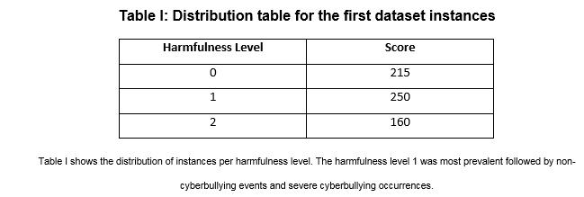

At the second level of annotation, the following guidelines were given:

* Sexuality – instances that contains both vulgar and filthy words.
* Physical Appearance – instances that contains cyberbullying statements with regards to the physical characteristics of a person.
* Intelligence – instances that attacks the mental capacity of a person.
* Race and Culture – instances that contains both racial and cultural discrimination.
* Social Rejection – instances that contains cyberbullying statements which isolates an individual from the society or degrades a person.
* Bad Description – instances that contains cyberbullying statements that pertains to the attitudes and behaviour of an individual; however, this categorization can be misused with the physical appearance.

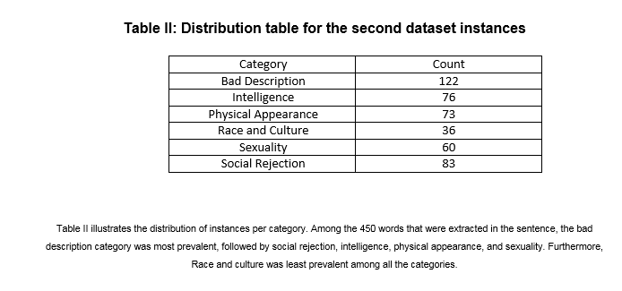

In the succeeding phases of the project, the researchers are planning to continue with the text pre-processing tasks that are needed in order to lessen the difficulty of extracting linguistic features from the text (which is the phase of the project that will come after the pre-processing phase). Feature selection will be implemented using the following methods: Bag of Words – which will yield bigrams and trigrams, and application of TF-IDF scores – which will aid in the process of determining the most relevant words in each cyberbullying category, as these scores will be used to evaluate the bigrams and trigrams of the instances resulting from the Bag of Words approach (the higher the score, the more relevant the term is). Profane words and words written in uppercase letters are going to be considered offensive by default.

The initial part of the experimentation phase begins with the establishment of classes involving the predefined classifications of cyberbullying expressions based on sensitive issues. This is to verify the accuracy of the model in terms of functioning side by side with features that are closely related to each other. This process will also determine which words can fall in more than one class so they can be given appropriate weights (feature weighting) – e.g. a particular word is more appropriate to be classified in this class compared to the other despite having the characteristics if being included in the latter class as well. The second part of the experimentation phase will take into consideration the final features that will be selected (or the most determining words for each cyberbullying classifier based on offensive issues). The group may either remove or add more features depending on the results the experiments will yield regarding the cyberbullying detection model’s accuracy.

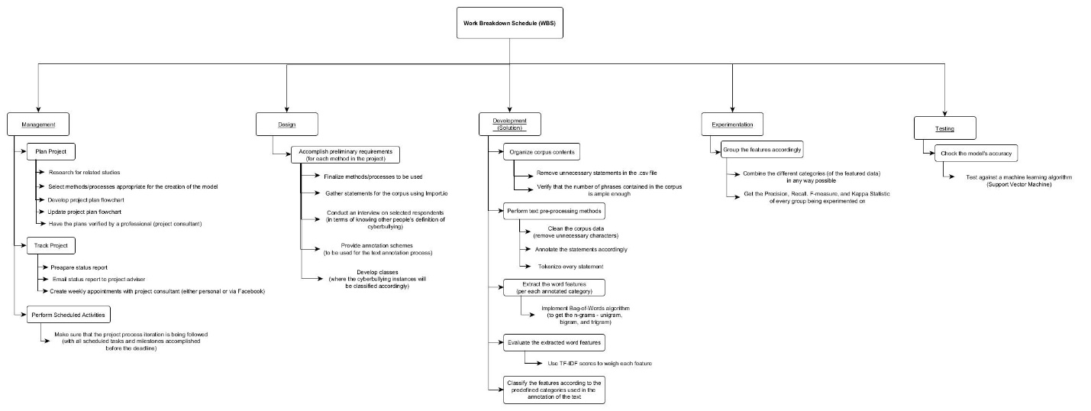

Work Breakdown Schedule (WBS)

**RESULTS AND DISCUSSIONS**

This section presents the outcome of the proponent's preliminary experiments.

The data was acquired from social networking sites such as Facebook, Twitter and YouTube; moreover, two classification tasks were carried out: cyberbullying event detection and the classification of text categories related to cyberbullying. Using the Special Text Replacement function in Excel, the dataset was normalized. The researchers get the frequency of each instance of the word under each category. Out of 625 statements that were extracted from the social media sites, the harmfulness level 1 was most prevalent with a frequency of 33%. It was followed by non-cyberbullying events, with a frequency of 41%. The occurrences of severe cyberbullying events were the least prevalent amongst the three classifications since it obtained a frequency of 26%.

At the second level of annotation, the bad description was the most prevalent with a frequency of 27%, it was followed by Social Rejection (18%), Intelligence (16%), Sexuality (13%), Physical Appearance (10%) and the category Race and Culture was the least prevalent among the six categories, it has a frequency of 8%.